App: Radio: Phase #1

Date: April 11th, 2023  
Domain: [https://radio.brickmmo.com](https://pixelate.brickmmo.com)

GitHub: <https://github.com/codeadamca/brickmmo-radio>

# Application Purpose:

The goal of this project is to create a 24/7 Ai-driven Web-based radio broadcast based on the

BrickMMO Lego city. The radio station will stream its content to a web interface, where anyone

can visit it from their browser, and listen to an AI voice read news stories, weather, and other

happenings around a fictional city.

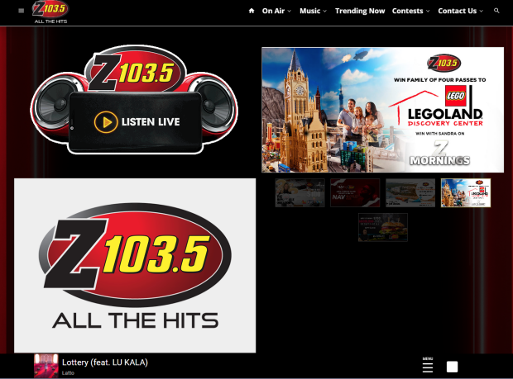

Current Radio website with “listen live” and live player

The radio broadcast will have many of the features of a current real-world radio station, in that it

will support segments. This could include music, games, contests, and even audience

interaction. Listeners would be able to interact with these segments through the website (take

part in polls, play games, etc).

As a developer, this application will focus on showcasing the ability of generative AI models and

how they can be used in tandem to create engaging content. It will also highlight my familiarity

with technology such as CMS development, database security, and API integration.

# Front-End:

Front end facing application will include the following features:

* A website to listen to the ongoing radio station
* Could include closed captions

# Back-End:

Application will include a control panel to achieve the following:

* Login to control panel
* Manage radio show commentary
* Add, edit, and delete show segments

# API:

Application API will include the following API calls:

| **Method** | **Endpoint** | **Description** | |
| --- | --- | --- | --- |
|  |  |  | |

There are no API requirements at this point.